### **Assignment 1 Solutions**

### **MapReduce and PageRank**

**Question 1**:

Suppose our input data to a map-reduce operation consists of integer values (the keys are not important). The map function takes an integer *i* and produces the list of pairs (*p*,*i*) such that *p* is a prime divisor of *i*. For example, map (12) = [(2,12), (3,12)]. The reduce function is addition. That is, reduce (*p*, [*i*1, *i*2, ..., *ik*]) is (*p*,*i*1+*i*2+...+*ik*). Compute the output, if the input is the set of integers 15, 21, 24, 30, 49.

**Answer 1: The output of map function is**

**map (15) = [(3, 15), (5, 15)] map (21) = [(3, 21), (7, 21)]**

**map (24) = [(2, 24), (3, 24)] map (30) = [(2, 30), (3, 30), (5, 30)]**

**map (49) = [(7, 49)]**

**These are the respective prime divisors of inputs**

**The output of reduce function is**

**reduce (2, 54), reduce (3,90), reduce (5,45), reduce (7, 70).**

**Question 2**:

Consider three Web pages with the following links:

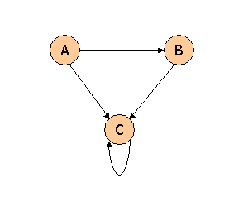

Suppose we compute PageRank with a β of 0.7, and we introduce the additional constraint that the sum of the Page Ranks of the three pages must be 3, to handle the problem that otherwise any multiple of a solution will also be a solution. Compute the Page Ranks *a*, *b*, and *c* of the three pages A, B, and C, respectively.

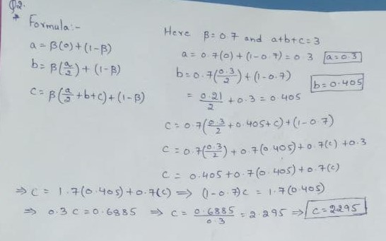

**Question 3**:

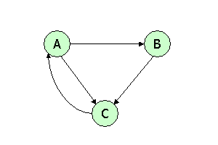

Suppose we compute PageRank with β=0.85. Write the equations for the Page Ranks *a*, *b*, and *c* of the three pages A, B, and C, respectively.

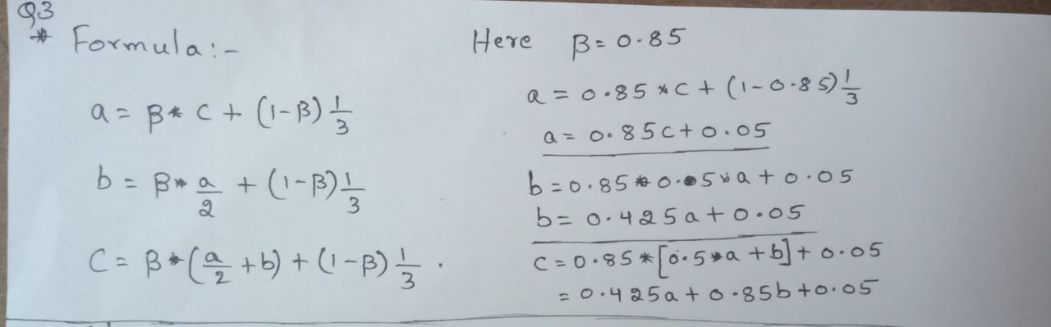

**Question 4**:

Assuming no "taxation," compute the Page Ranks *a*, *b*, and *c* of the three pages A, B, and C, using iteration, starting with the "0th" iteration where all three pages have rank *a = b = c* = 1. Compute as far as the 5th iteration, and also determine what the Page Ranks are in the limit.

